Iteration 3

1. **Meet time and demo**

We emailed with Theresa to talk about our recent activities. We told her we add the email function in the interface. According to user story 4, customers can send electronical recipe to donors via email. By doing this, we can reduce customers’ work load and improve their efficiency.

1. **Implement user story**

**Feature:** Send electronic receipt to donors via email

As a high-efficiency food bank

So that receipts are easy to be kept

I want to send electronic receipts to donors automatically

1. **Design diagram**

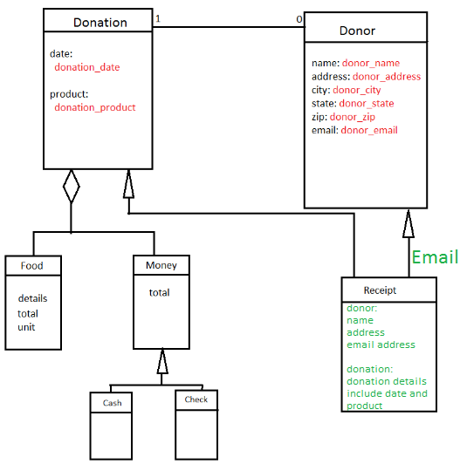

In this diagram, we add a new function in green—Email. When the donor finish the donation, the system will record the information the donator entered. All the information will print out in a standard electronical form and be sent to donor’s email address. The information include the donate date, the donate product’s details, the donor’s name, address and email.

1. **Test results**

**Cucumber test result:**

**Rspec test result:**

1. **Related links**

Webpage:

Github: https://github.com/zhengkai2001/BV-Food-Bank.git

Pivotal Tracker: <https://www.pivotaltracker.com/story/show/132130763>